**REPORT**

|  |
| --- |
| **Experiment 1: Non-inverting Amp. vs Inverting Amp.** |

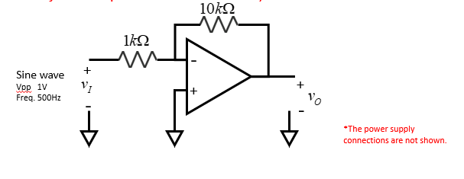

1-1

vin and vout waveform in the same graph with proper scale and measurement, including Vpp and maximum and minimum.

(1pic)

|  |  |  |  |
| --- | --- | --- | --- |
| vin,pp (V) | vout,pp (V) | Measured voltage gain; Av (V/V) | Theoretical voltage gain; Av (V/V) |
| **1.04** | **-9.68** | **-9.3** | **-10** |

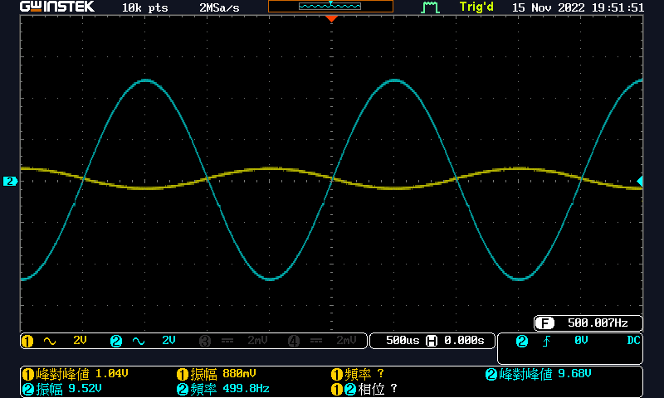

Question:

Please attach your LTSPICE simulation result. (Both schematic and waveform)

(2pic)

Comparison:

A=Vout,vpp/ Vin,vpp

1-2

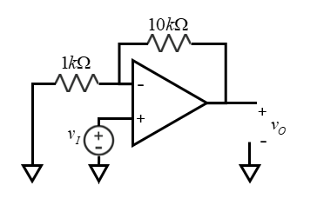

vin and vout waveform in the same graph with proper scale and measurement, including Vpp and maximum and minimum.

(1pic)

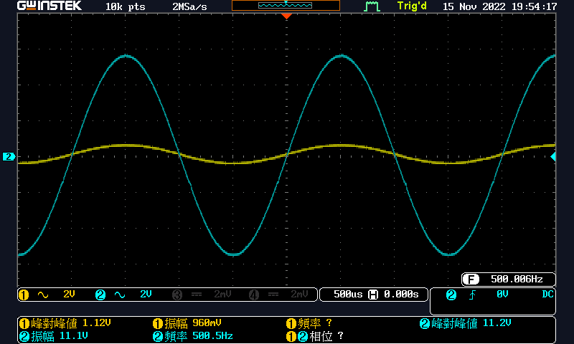

|  |  |  |  |
| --- | --- | --- | --- |
| vin,pp (V) | vout,pp (V) | Measured voltage gain; Av (V/V) | Theoretical voltage gain; Av (V/V) |
| **1.12** | **11.2** | **10** | **10** |

Question:

Please attach your LTSPICE simulation result. (Both schematic and waveform)

(2pic)

Comparison:

A=Vout,vpp/ Vin,vpp

|  |
| --- |
| **Experiment 2: Weighted Adder** |

Please use appropiate measurment and show result in proper scale

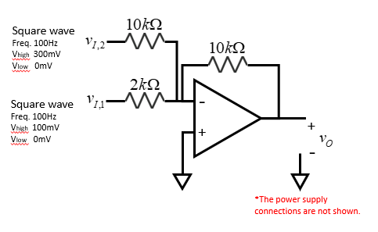

|  |  |  |  |
| --- | --- | --- | --- |
| vin1,pp (V) | vin2,pp (V) | Measured vout,pp (V) | Theoretical vout,pp (V) |
| **104** | **320** | **860** | **800** |

in1 & in2 waveform

(1pic)

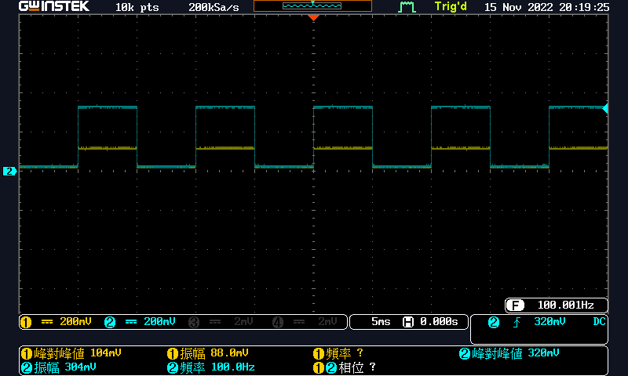

in1 & out waveform

(1pic)

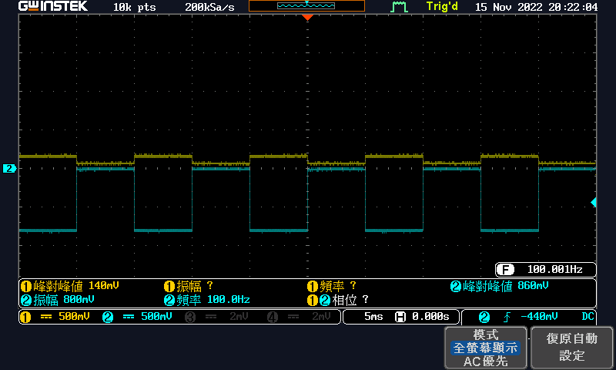

in2 & out waveform

(1pic)

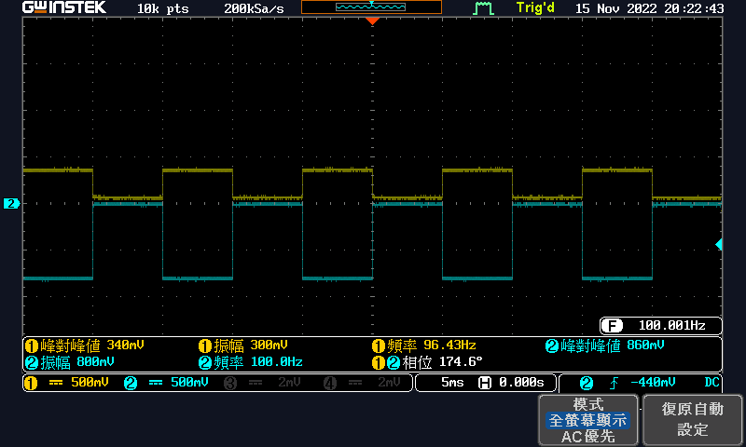

Question:

Please derive the equation for vout. Use symbol (vin1, vin2, R1, R2, R3, etc.) to represent.

$$i=\frac{v_{I,1}-v_{1}}{R_{1}}+\frac{v_{I,2}-v_{1}}{R_{2}}=\frac{v_{1}-v_{O}}{R_{f}}$$

$$=\frac{v_{I,1}}{R_{1}}+\frac{v_{I,2}}{R_{2}}=\frac{-v_{O}}{R_{f}}$$

$$⟹v_{O}=-\frac{R_{f}}{R_{1}}v_{I,1}-\frac{R_{f}}{R_{2}}v_{I,2}$$

Please attach your LTSPICE simulation result. (Both schematic and waveform)

(2pic)

Discuss:

|  |
| --- |
| **Experiment 3: Active filter** |

Please use appropiate measurment and show result in proper scale.

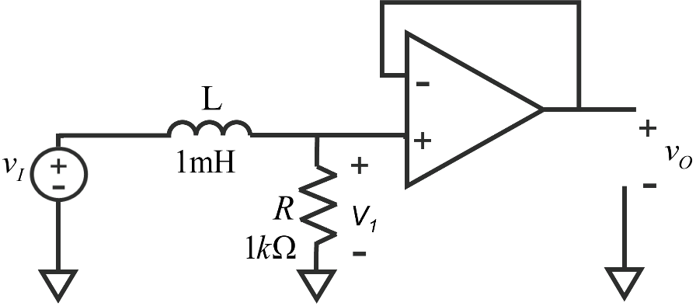

1kΩ

|  |  |
| --- | --- |
|  |  |
|  |  |

1.

|  |  |  |
| --- | --- | --- |
| Frequency (Hz) | 50kHz | 300kHz |
| V,I,pp(V) | 4.88 | 4.72 |
| Vo,pp(V) | 4.64 | 2 |
| V1,pp(V) | 4.72 | 2.8 |

2.

50k Hz Vin , V1, and Vout waveform

(1pic)

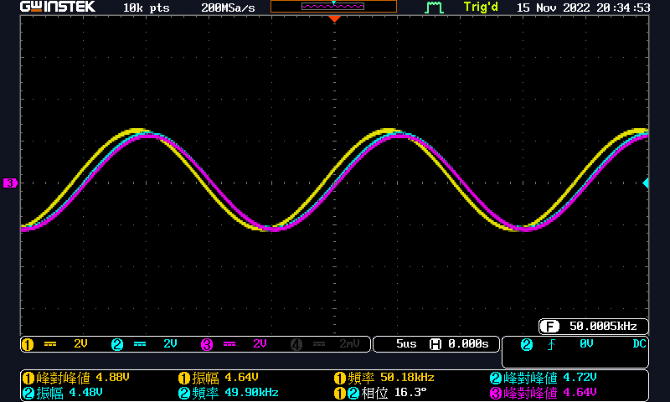

300k Hz Vin , V1, and Vout waveform

(1pic)

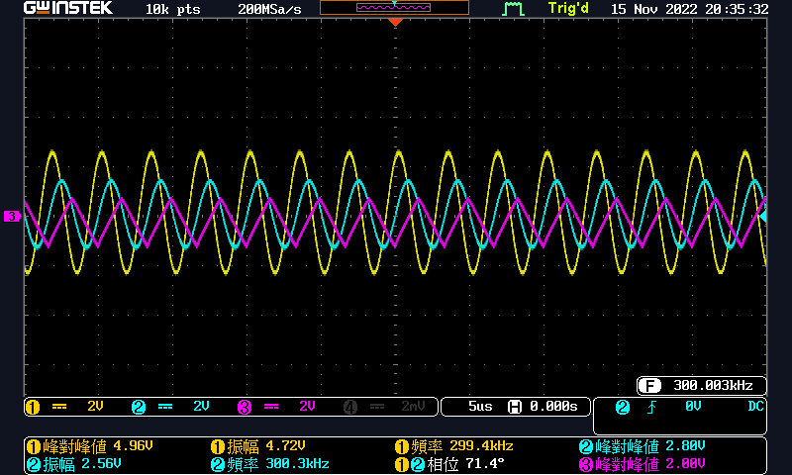

3.

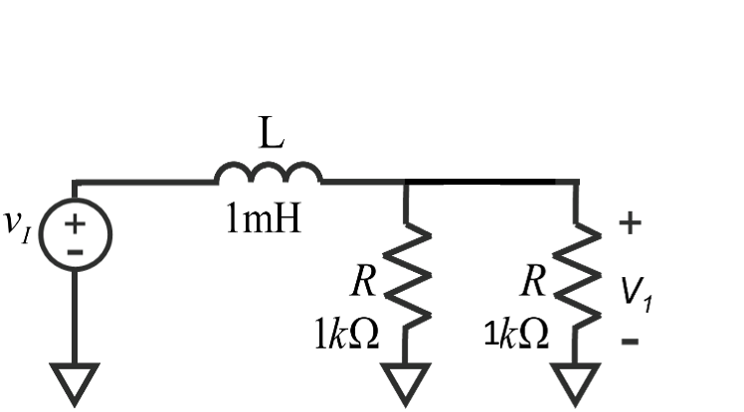

300k Hz Vin and V1 waveform, turn off OP.

(1pic)

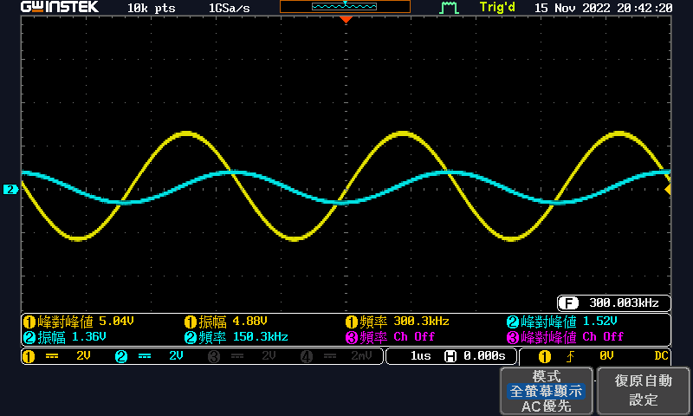

4.

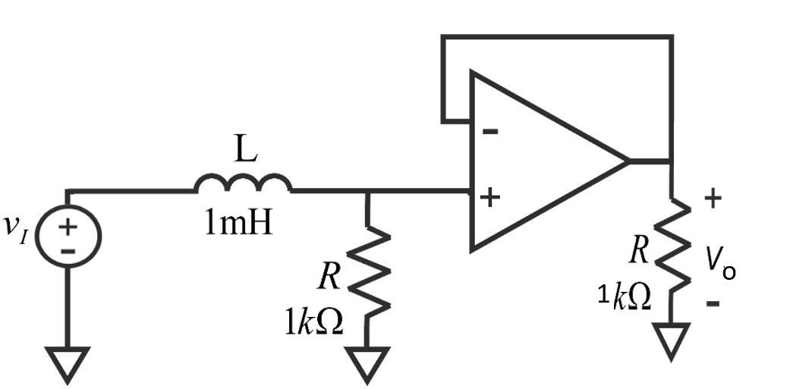

300k Hz Vin and Vo waveform

(1pic)

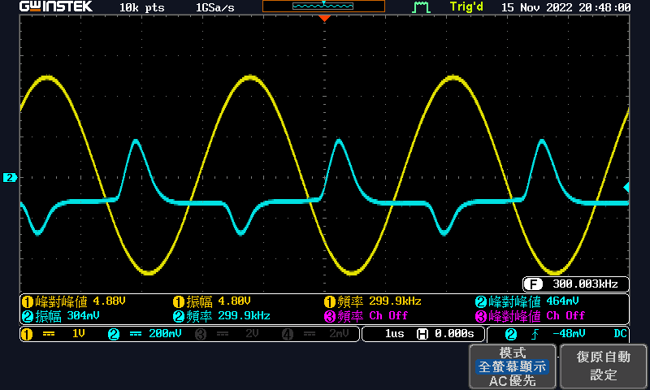

Question:

Please attach your LTSPICE simulation result. (Both schematic and waveform)

(2pic)

Discuss: